**Assignment -1**

Python Programming

|  |  |
| --- | --- |
| Assignment Date | 19 September 2022 |
| Student Name | Shunmathi.D |
| Student Roll Number | CITC1904048 |
| Maximum Marks | 2 Marks |

**Question-1:**

**Write a python program to split the string**

|  |
| --- |
| **Solution:** |
|  | s = "Hi there Sam!"  x=s.split()  print(x) |

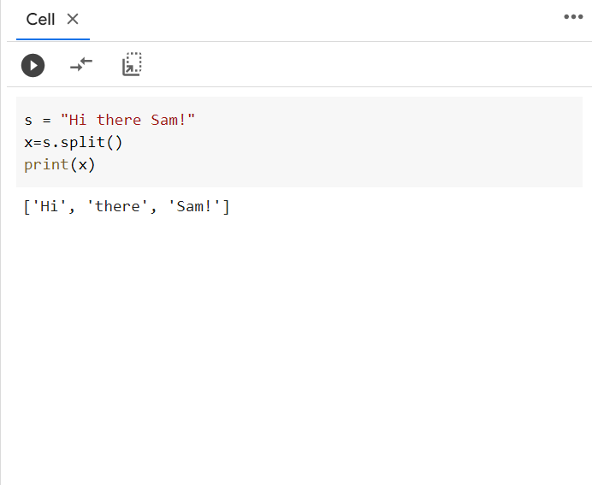

**Question-2:**

## Write a program to Use .format() to print the following string.

**Output should be: The diameter of Earth is 12742 kilometers.**

|  |
| --- |
| **Solutin:** |
|  | planet = "Earth"  diameter = 12742  print(f"The diameter of Earth is {diameter} kilometers.") |

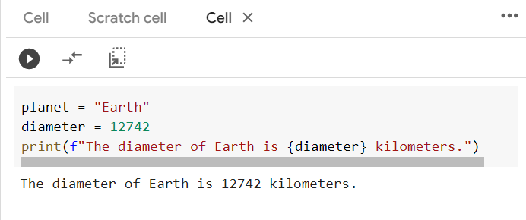

**Question-3:**

**Write a python program to grab hello from dictionary of words**

|  |
| --- |
| **Solution:** |
|  | d = {'k1':[1,2,3,{'tricky':['oh','man','inception',{'target':[1,2,3,'hello']}]}]}  print(d['k1'][3]["tricky"][3]['target'][3]) |

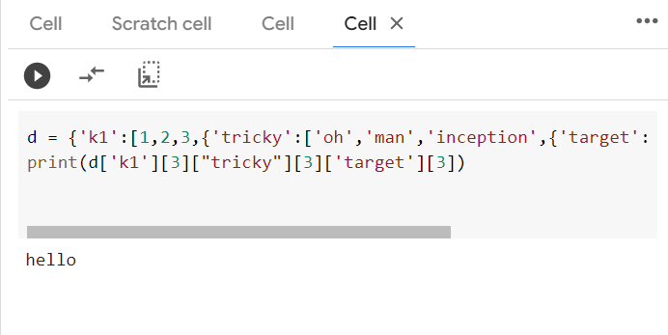

**Question-4:**

**Write a python program to import numpy to create array of 10 zeroes**

import numpy as np

array=np.zeros(10)

array=np.ones(10)*5

**Question-5:**

**Write a python program to import numpy to create an array of all the even integers from 20 to 35**

array=np.arange(20,35,2)

**Question-6:**

**Write a python program to import Create a 3x3 matrix with values ranging from 0 to 8**

x =  np.arange(0, 9).reshape(3,3)

**Question-7:**

## Write a python program to Concatenate a and b

## a = np.array([1, 2, 3]), b = np.array([4, 5, 6])

a = np.array([1, 2, 3])

b = np.array([4, 5, 6])

np.concatenate((a, b), axis=None)

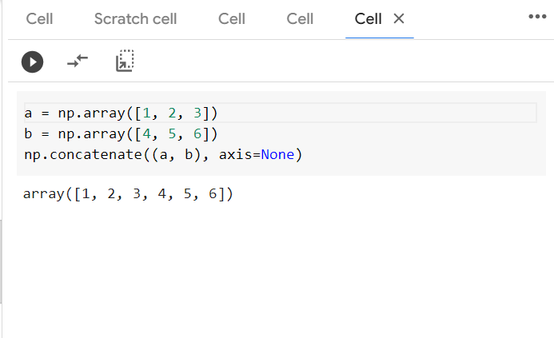

## Question-8: Create a dataframe with 3 rows and 2 columns

import pandas as pd

df = pd.DataFrame()

## Question-9: Generate the series of dates from 1st Jan, 2023 to 10th Feb, 2023

import datetime

import pandas as pd

test_date = datetime.datetime.strptime("01-01-2023", "%d-%m-%Y")

K = 41

date_generated = pd.date_range(test_date, periods=K)

print(date_generated.strftime("%d-%m-%Y"))

## 

## Question-10: Create 2D list to DataFrame

**lists = [[1, 'aaa', 22], [2, 'bbb', 25], [3, 'ccc', 24]]**

import pandas as pd

lists = [[1, 'aaa', 22], [2, 'bbb', 25], [3, 'ccc', 24]]

df=pd.DataFrame(lists)

print(df)

